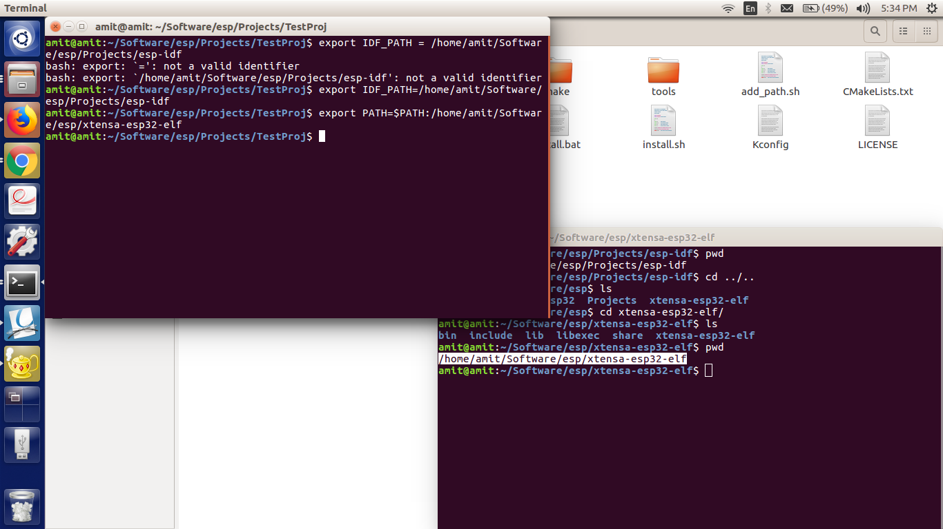
Use the commands given in the screenshots with ( ../../bin) at the last to export the path.

If we change the profile then we need to again set the xtensa path or restart the system.

